* **How to load a project to Github?**

Git’s just a tool that allows any user to analyze each single change inside a file that’s into a carpet wich’s already inicialized as a local repo. It’s because of this that we’ll take a look at how to load our projects to a virtual repo, as Github.

1. **Download Git:**

Versions Control Sistem Git, must be taken as a essential tool as for checking out numerous versions and changes asigned to a specific file.

**Download here:** [**https://git-scm.com**](https://git-scm.com)

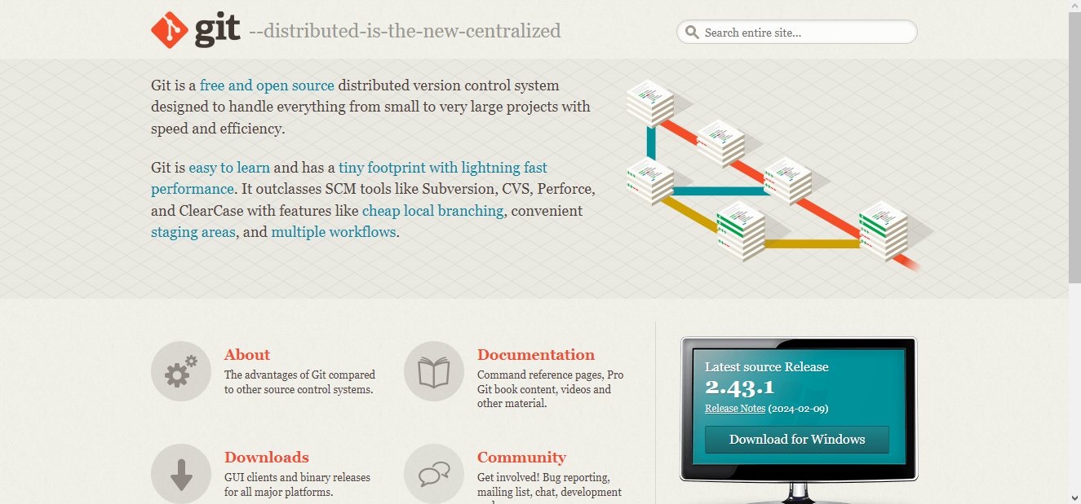

1. **Create a Github account and log in on it:**

If you’re thinking about loading series of docs to a virtual repo, it’s essential to have already created an account in Github, place where all our documents will be saved.

**Webpage:** [**https://github.com**](https://github.com)



1. **Download VSC (Visual Studio Code):**

As well, to keep progressing into our theory to create both repos, it’s essential to have already downloaded an IDE, such as VSC, wich’ll allow us to make new files with specific formats (.HTML, .js, .txt).

**Download here:** [**https://code.visualstudio.com**](https://code.visualstudio.com)

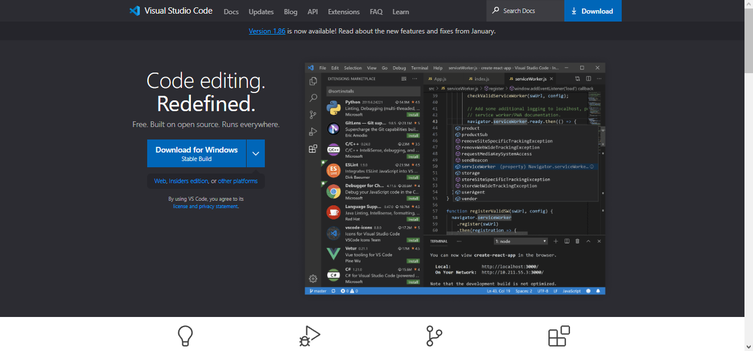

1. **Create a new PC folder using files explorer:**

Just after following each single last steps, it’s required to open files explorer, where we must create a new folder, one we’ll use as local repo once we inicialize it by Git.

1. **Commands to run at Gitbash window:**

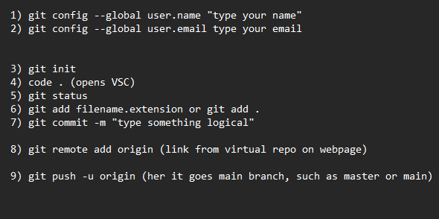

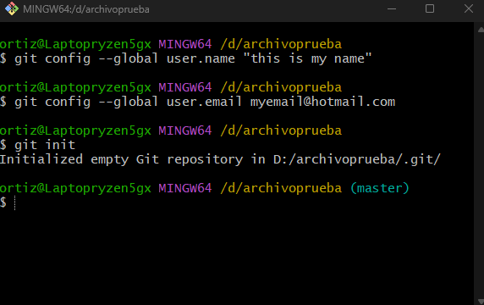

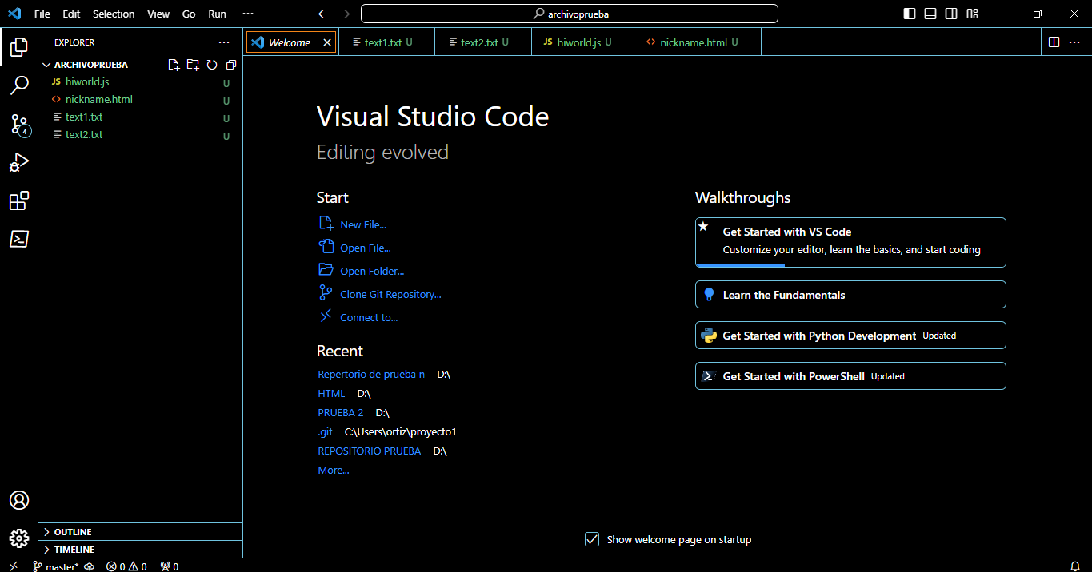

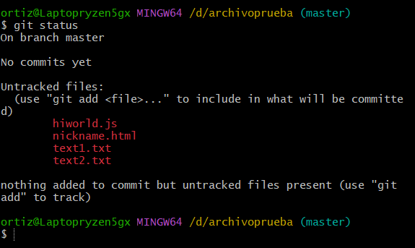

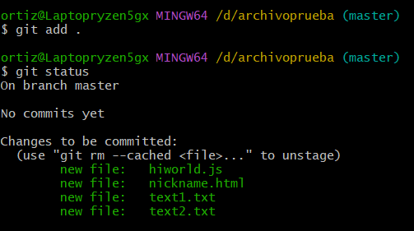

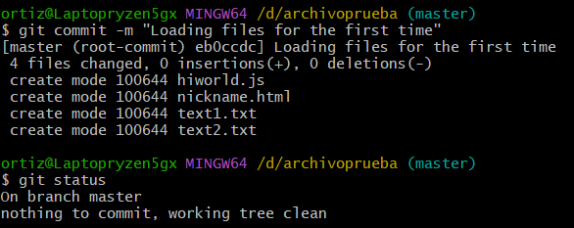

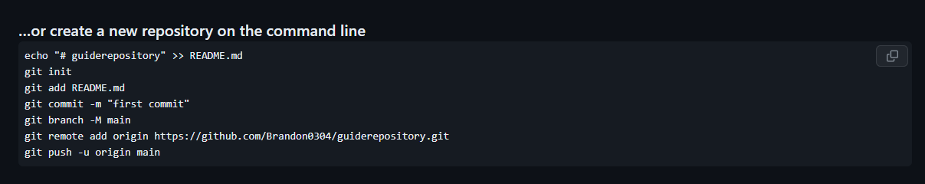

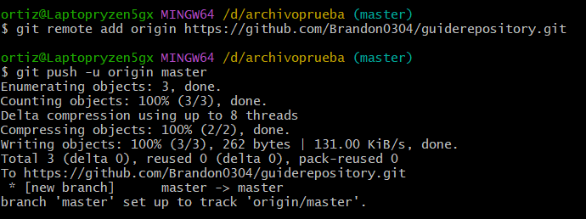

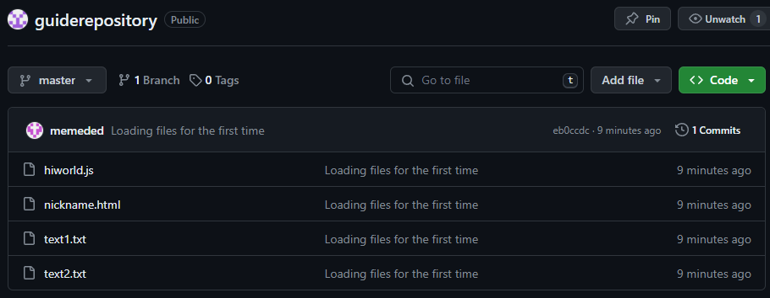

**Now you’ve created your both local and virtual repos, congratulations!**

**Punto 2.6:** [**https://miro.com/welcomeonboard/WlMwZzF0TUh0Y1l6cUhkTlp4WmM0WXl2UWhnVExQUlh4WXVidWxUWFJJMG9uc05IQkdmeVRjVTRNTGJONFVwa3wzNDU4NzY0NTc4NjA4OTI5NTE0fDI=?share_link_id=974229592402**](https://miro.com/welcomeonboard/WlMwZzF0TUh0Y1l6cUhkTlp4WmM0WXl2UWhnVExQUlh4WXVidWxUWFJJMG9uc05IQkdmeVRjVTRNTGJONFVwa3wzNDU4NzY0NTc4NjA4OTI5NTE0fDI=?share_link_id=974229592402)